**Course : LOG8371E**

Software Quality Engineering

**Assignment #2 : Software Quality plan, testing strategies and evaluation of software quality**

|  |  |  |  |  |  |
| --- | --- | --- | --- | --- | --- |
|  |  | **By :** | | |  |
|  |  |  |  |  |  |
|  |  |  |  |  |  |
|  |  | Students Identification | |  |  |
|  |  |  |  |  |  |
|  | Student #1 |  | Freddy Sossa | |  |
|  |  |  |  | |  |
|  | Student #2 |  | Sahil Dahake | |  |
|  |  |  |  |  |  |

**Submitted to :**

Mahsa Hadian

**On :**

November 9, 2019

**Table of contents**

Introduction

1. Software Quality Plan
2. Tests
3. Docker Deployment
4. Profiling with JProfiler
5. Loads tests with JMeter
6. Monitoring for docker
7. Demonstrative Video

**Introduction**

Weka (Waikato Environment for Knowledge Analysis) is an open source software developed at the University of Waikato in New Zealand. It’s a data mining application that contains a collection of tools and algorithms for data analysis and predictive modeling. This is app is commonly use in agricultural domains and more recently for educational and research purposes. This tool is being also used for academic and research purposes, so it is important to ensure that the results of the data processing done using it are accurate and that the application is working properly. It will therefore be useful to perform a series of tests to ensure the quality and smooth operation of the software. This document serves as a software quality plan. We will be working on two classifications and clustering algorithms and one regression algorithm.

Researchers use this software and rely on it to advance their research. Whether they are researchers in artificial intelligence or researchers in other fields using artificial intelligence during their search, it is important for them that the software has a good quality. It is crucial to properly process the data to obtain relevant results for researchers.

1. **Software Quality Plan**

This document will essentially cover five main features we have chosen. We can therefore say that all those features are considered as our functional requirements. First of all, it’s important to describe those features in order to have an idea of which tasks each feature perform.

1. Main features

* Classifications algorithms
* NaiveBayes Algorithm

Naive Bayes Algorithm is a technique that helps to construct classifiers. Classifiers are the models that classify the problem instances and give them class labels which are represented as vectors of predictors or feature values. It is based on the Bayes Theorem. It is called naive Bayes because it assumes that the value of a feature is independent of the other feature i.e. changing the value of a feature would not affect the value of the other feature. It is also called as idiot Bayes due to the same reason. This algorithm works efficiently for large data sets, hence best suited for real-time predictions.[1]

* LinearRegression

Linear Regression is a machine learning algorithm based on supervised learning. It performs a regression task. Regression models a target prediction value based on independent variables. It is mostly used for finding out the relationship between variables and forecasting. Different regression models differ based on – the kind of relationship between dependent and independent variables, they are considering, and the number of independent variables being used. [2]

* Clustering Algorithms
* FarthestFirst

In [computational geometry](https://en.wikipedia.org/wiki/Computational_geometry), the farthest-first traversal of a bounded [metric space](https://en.wikipedia.org/wiki/Metric_space) is a sequence of points in the space, where the first point is selected arbitrarily and each successive point is as far as possible from the set of previously-selected points. The same concept can also be applied to a [finite set](https://en.wikipedia.org/wiki/Finite_set) of geometric points, by restricting the selected points to belong to the set or equivalently by considering the finite metric space generated by these points. For a finite metric space or finite set of geometric points, the resulting sequence forms a [permutation](https://en.wikipedia.org/wiki/Permutation) of the points, known as the greedy permutation. [3]

* HierachicalCluster

Hierarchical clustering (also called hierarchical cluster analysis or HCA) is a method of [cluster analysis](https://en.wikipedia.org/wiki/Cluster_analysis) which seeks to build a [hierarchy](https://en.wikipedia.org/wiki/Hierarchy) of clusters. Strategies for hierarchical clustering generally fall into two types:[[1]](https://en.wikipedia.org/wiki/Hierarchical_clustering#cite_note-clusteringMethods-1)

* Agglomerative: This is a "[bottom-up](https://en.wikipedia.org/wiki/Top-down_and_bottom-up_design)" approach: each observation starts in its own cluster, and pairs of clusters are merged as one moves up the hierarchy.
* Divisive: This is a "[top-down](https://en.wikipedia.org/wiki/Top-down_and_bottom-up_design)" approach: all observations start in one cluster, and splits are performed recursively as one moves down the hierarchy.

In general, the merges and splits are determined in a [greedy](https://en.wikipedia.org/wiki/Greedy_algorithm) manner. The results of hierarchical clustering are usually presented in a [dendrogram](https://en.wikipedia.org/wiki/Dendrogram). [4]

* Association algorithms
* FPGrowth

FpGrowth Algorithm (Frequent pattern growth) is an improvement of apriori algorithm. FP growth algorithm used for finding frequent itemset in a transaction database without candidate generation. It allows frequent itemset discovery without candidate itemset generation. Two step approaches as building a compact data structure called the FP-tree (built using 2 passes over the data-set) and extracting frequent itemsets directly from the FP-tree (traversal through FP-Tree).

* KStar

K* is an instance-based classifier, that is the class of a test instance is based upon the class of those training instances similar to it, as determined by some similarity function. It differs from other instance-based learners in that it uses an entropy-based distance function. [6]

1. Criterias, Objectives and Validation measures

|  |  |  |
| --- | --- | --- |
| **Criteria** | **Sub-Criteria** | **Validation measures** |
| Functionality | Functional correctness | The system delivers correct results 99% of the time |
| Functional completeness | The reviewer of the patch judges the functionality added relevant. |
| Reliability | Recoverability | The system must be able to recover anytime that a crash occurs |
| Fault tolerance | The system must correct itself in case of errors so as not to mislead the researchers 90% of the time. |
| Maintainability | Analysability | Adding a feature changes to maximum 30 lines of existing code. |
| Reusability | Cannot be tested automatically. |
| Testability | 70% of the functional requirements or not  functional are covered by the tests. |
| Performance efficiency | Capacity | The system must be able to support datasets of maximum size of 3 megabytes. |
| Time-behavior | The system must have a maximum response time of 10s. The system should not slow down the processing of queries when it scales automatically. |
| Resource utilization | The system must start additional servers automatically when the servers have a CPU utilization rate greater than 85% for at least 5 seconds. The system must automatically reduce the number of servers when they have a CPU rate lower than 50% for at least 5 seconds. |

1. Validation Strategy

The validation strategy is composed of several activities. First, to make sure we always have a functional product, the development will be in continuous integration methodology with a versioning tool. Every new feature will be developed on a local version of the product. When completed, this release will be subject to a code review involving developers who have not been involved in the development of the new feature. When the future is complete and accepted by the dev team, the next step is the migration to the local environment of the quality assurance.

Several tests will be executed on the QA environment (whether they are manual or automated tests). All the test will be running according to a series of use cases defines by quality assurance engineers. The purpose of those tests is to detect behavioral problems and user interfaces bias. When a problem is detected, the development team returns to the local version and resumes the start development cycle. If no problem is detected, the experimental version is merged with the main version of the product.

In the meantime, the development of new functionalities, new software tests will be developed. These tests will follow the black box methodology, thus ensuring a suite of unit tests verifying component outputs according to their inputs. The product test suite is manually run by developers with every change made to their local version of the software. When a code review request is created, all of the product's test suites are rolled automatically. Code review is only open if the test report indicates no failure and a percentage coverage of the new product feature of at least 80%. In addition, each merger with the main version, the test suites are once again executed to ensure at any time a major version of the product without error. We will also be using **reviews** as validation strategy. We are not the final users, so it’s important for the final user to have their say on the work. The thing is that it’s important to make sure that they understand easily how it works and is working the way they expected it to work. It’s also useful to early detect bugs and problems.

1. Planification

* Team and work

We are working in a team of 4 people for the tests : 2 Developers, 1 Functional Analysts and 1 Tester. The team will be working in a Scrum agile method. The project will be on two months, then eight weeks. Each sprint will last three weeks except the last one which will last 2 weeks. We have chosen a duration of 3 weeks because it’s the optimal duration ( 4 is enough and 2 is not enough to finish what is started).

1. **Tests**
2. Tests Plan
   1. Introduction

To ensure that we have a quality product, it is imperative to test our software and validate the results. A test plan is needed to properly target relevant tests for our software. This test plan will include all of the requirements to be tested as well as our testing strategies with the different types of tests that we will use.

* 1. Requirements

Now, we have to identify the requirements that will be tested (functional and non-functional). Our functional requirements are basically the functionalities of our reduced version of Weka while our non-functional requirements match our quality criteria.

1.2.1. Functional requirements

1.2.1.1. Association algorithm FPGrowth

1.2.1.2. Classification algorithm NaiveBayes

1.2.1.3. Classification algorithm LinearRegression

1.2.1.4. . Classification algorithm KStar

1.2.1.5. Clustering algorithm FarthestFirst

1.2.1.6 Clustering algorithm HierarchicalCluster

1.2.2. Non-functional requirements

1.2.2.1. Reliability

|  |  |
| --- | --- |
| Recoverability | It involves a set of policies, tools and procedures to enable the recovery or continuation of vital technology infrastructure and systems following a [natural](https://en.wikipedia.org/wiki/Natural_disaster) or [human-induced](https://en.wikipedia.org/wiki/Man-made_hazards) [disaster](https://en.wikipedia.org/wiki/Disaster). It focuses on the IT or [technology systems](https://en.wikipedia.org/wiki/Technology_systems) supporting critical business functions,as opposed to [business continuity](https://en.wikipedia.org/wiki/Business_continuity), which involves keeping all essential aspects of a business functioning despite significant disruptive events. |
| Fault tolerance | Enable a [system](https://en.wikipedia.org/wiki/System) to continue operating properly in the event of the failure of (or one or more faults within) some of its components |

1.2.2.3. Maintainability

|  |  |
| --- | --- |
| Modularity | Degree to which a system or program is composed of components so that a change to a component has an impact minimal on others |
| Reusability | Degree to which an element can be used in more than one system or in construction other elements |
| Testability | Degree of efficiency and effectiveness with which a test criterion can be established for a system, a product or component and presence of tests that can determine if these criteria are met |

1.2.2.4. Performance efficiency

|  |  |
| --- | --- |
| Time behavior | Compliance of maximum limits of certain system parameters with the requirements. |
| Resource utilization | Compliance of the quantity and types of resources used by the system with the requirements. |
| Capacity | Compliance of response or processing times and system throughput rate with requirements |

* 1. Testing
     1. Functions tests

|  |  |
| --- | --- |
| Testing Goal: | Validate the appropriate implementation of use cases |
| Testing Methods: | Unit tests such as validation of the return value or the expected change |
| Validation measures: | All the units tests are passing |

* + 1. Regression tests

|  |  |
| --- | --- |
| Testing Goal: | Avoid a bug being introduced during a bug fix  or any other changes to the software |
| Testing Methods: | Automated tests with continuous integration tools (Travis CI, Jenkins) of unit tests |
| Validation measures: | All the previous tests are still passing after the changes. |

* + 1. Test suites

|  |  |
| --- | --- |
| Testing Goal: | Test a software to show that it has a certain set of  behavior in different situations |
| Testing Methods: | Launch a collection of test cases with instructions and a particular configuration |
| Validation measures: | The set of system behaviors during the execution of the test following are those expected. |

* + 1. Stress Tests

|  |  |
| --- | --- |
| Testing Goal: | Ensure that our system is minimally efficient to  support the expected capacity. |
| Testing Methods: | Perform performance tests at different loads and levels |
| Validation measures: | The results of the performance tests meet the requirements stated at the beginning of the project and the breaking point exceeds the threshold. |

* + 1. Performance tests

|  |  |
| --- | --- |
| Testing Goal: | Validate that our practical performance matches those established in our requirements. |
| Testing Methods: | Measurement of the response time for different operations, the transaction rate and other metrics of queries processing. |
| Validation measures: | The average response time does not exceed the threshold in the requirements with a moderate transaction rate but does not result in server failure if it is higher. |

1. **Docker Deployment**

To deploy with docker, the first step is to set up. First of all, install all the required dependencies. After that, the different steps are :

* Building docker Image
* Clone the repository :

git clone <https://github.com/jguwekarest/jguwekarest.git>

* Access the folder : cd jguwekarest
* Compile the war (Web Application Archive) with maven:

mvn clean package

* Build the docker image :

Docker build -t username/jguwekarest .

* Check the built images : docker images
* Running the Docker container
* Run the mongodb container as Database:

docker pull mongo

docker run –-name mongodb -d mongo

* Run the local image as local container:

docker run -p 8080:8080 –link mongodb:mongodb username/jguwekarest .

* Load the Swagger-UI in a browser

htpp://localhost:8080/

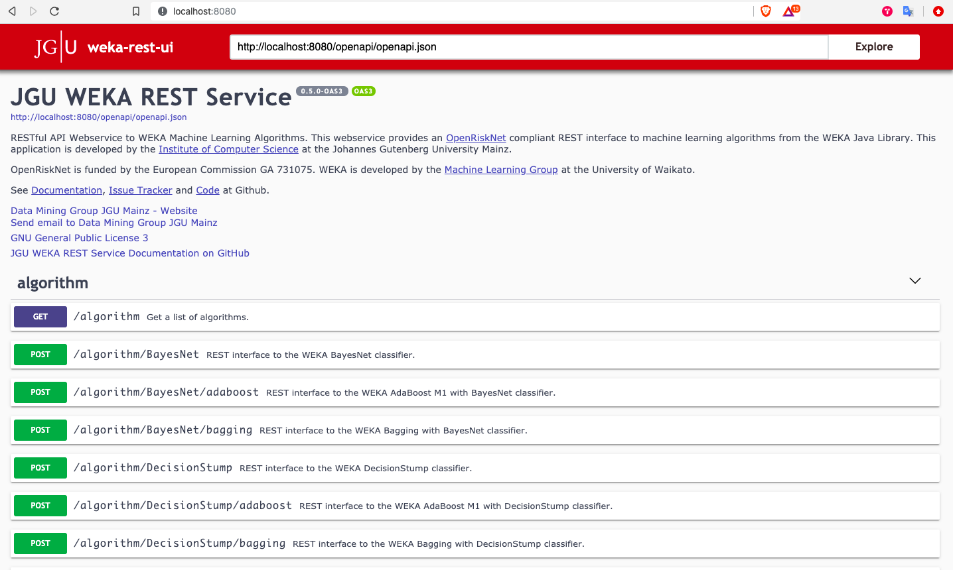

1. **Profiling with JProfiler**

In order to profile our Weka version, which is running on a docker container with JProfiler, we have first to make some changes to the Dockerfile. The goal here is to install le same JProfiler version as on our computers in the container we are using. Plus, we need to publish the port used by JProfiler in order to link it with the JVM. Here are the changes made in the Dockerfile :

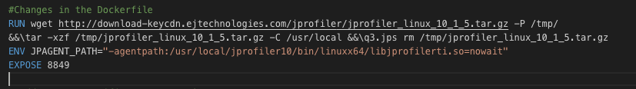

We need to rebuild the image et restart the container by specifying the used port:

docker build IMAGE

docker run -p 8080:8080 -p 8849:8849 --link mongodb:mongodb IMAGE

Once the container is started, we have to access to it and execute JProfiler :

docker exec -it CONTAINER

cd /user/local/jprofiler9/bin

./jpenable

JProfiler will be launched and ask for the working mode and the port. We enter 1 for the mode and 8849 for the port.

Now, to connect to the JVM inside the Docker, you have to download the JProfiler client using the link:

<https://www.ejtechnologies.com/download/jprofiler/files>.

Once JProfiler installed and working, you must select the "Attach to a running JVM" option. On the new window, select the option "On another computer". Enter the IP address of the Docker container and port 8849, followed by the "Start" button. We then created four scenarios using JMeter (a reduced load scenario, a medium load scenario, an increased load scenario, and an exceptional increased load scenario). These scenarios can be seen in the q3.jmx file provided in the GitHub repo. Scenarios run multiple Get and Post HTTP requests using datasets found at:

<https://storm.cis.fordham.edu/~gweiss/datamining/datasets.html>.

The selected files are available in the dataset folder of the GitHub repo. In addition, scenarios launch multiple threads to simulate different users. The results of these scenarios are appended and also available :

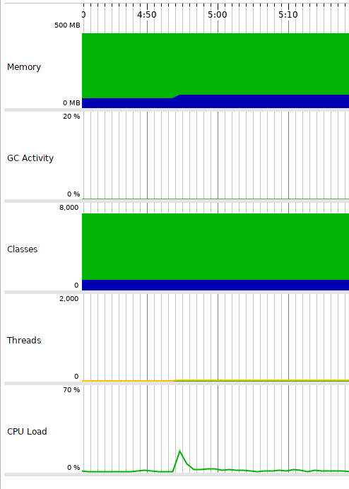

*Figure 1: Result of the reduced load scenario.*

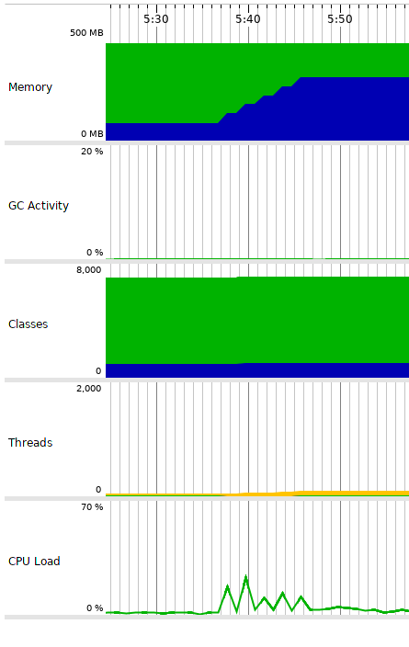

*Figure 2: Result of the average load scenario.*

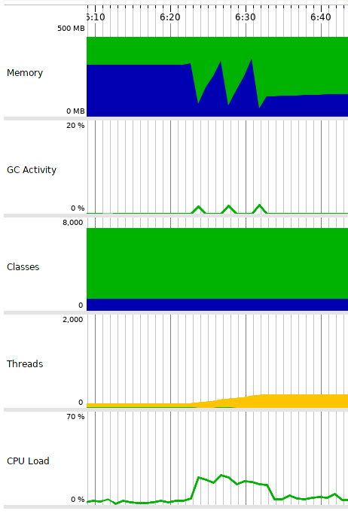

*Figure 3: Result of the increased load scenario.*

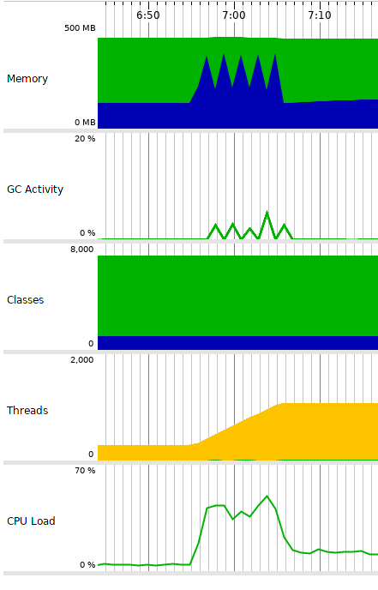

*Figure 4: Result of the exceptional increase load scenario.*

1. **Load Tests with JMeter**

To perform the load tests of our API, we used Jmeter to launch the queries as described in section 3. Since Jmeter is a java executable, we just need to get it at : <https://jmeter.apache.org/download_jmeter.cgi>.

In addition, it is necessary to have the containers Weka, and Mongo functional. To obtain these, simply follow the steps described in question 2 (Docker Deployment).

The execute JMeter, you have to use the command :

Java -jar pathTo/ApacheJMeter.jar

The results are in CSV form with a * .jtl extension. It is not directly obvious to read this type of file. Therefore, additional processing is required to establish the graphs. To do this, we used a jmeter plugin function that can be found at <https://jmeterplugins.org/wiki/RespTimesDistribution/>. Once the results are obtained, we add a graphical element, 'jp@gc - Responce Times Distribution', to process the data.

The graphs obtained are:

Figure :Distributions of Response Times - Reduced Loads.

Figure : Distributions of Response Times - Average Loads.

Figure : Distributions of Response Times - Increased Loads.

Figure : Distributions of Response Times - Exceptional Loads.

Figure : Distributions of Response Times - Exception Load (without calling the GET /model )

1. **Monitoring for Docker**

To examine the CPU thresholds of our application, we will use the "docker stats" command. First, we noticed that the CPU threshold used by the jguweka container rose to around 300% of use.

Subsequently, we did exactly the same manipulation and summarized in the following table the CPU rate used compared to the number of jguweka containers instantiated.

|  |  |
| --- | --- |
| Number of Jguweka instances | CPU rate per instance (%) |
| 1 | 300 % |
| 2 | 190 – 210 % |
| 3 | 120 – 140 % |
| 4 | 90 – 120 % |
| 5 | 40 – 60 % |
| 6 | 40 – 60 % |
| 7 | 20 – 50 % |

To have an optimal level of performance for our application, we recommend the use of 5 containers when the load is maximum and 1 container when the load is minimal to have the best performance. An optimal consumption would be less than about 70% of the CPU and that is why we have chosen to instantiate a maximum of 5 containers and no more.

1. **Demonstrative video**

Link to the video : <https://youtu.be/hc7dzKwQ6-M>

GitHub link : <https://github.com/fredsossa1/jguwekarest>

Resource consumption tutorial of our application: :

1- JMeter Installation

1.1- Download the file:

<http://mirror.csclub.uwaterloo.ca/apache//jmeter/binaries/apache-jmeter-5.2.tgz>

1.2- Unzip the file and launch the command :

sudo tar -xf apache-jmeter-5.2.tgz

cd apache-jmeter-5.2/bin/

sudo ./jmeter.sh

* To see the statistics about container use, we can use :

“sudo docker stats”

We will launch the work and fill the table :

|  |  |  |  |
| --- | --- | --- | --- |
| Container numbers | %CPU at initialization | %CPU at reduced load | %CPU at heavy  load |
| 1 | 300% | 0.11% | 160% |

2- Configuration of docker-compose.yml to allow scaling

* Delete the line “container_name: jguwekarest“
* Replace the port “8081:8080” by “8080”
* We will rerun the program et fill the table

We are connected with our 5 containers. Unfortunately, the tests don’t work because we have to target the containers individually by their port.

|  |  |  |  |
| --- | --- | --- | --- |
| Container numbers | %CPU at initialization | %CPU at reduced load | %CPU at heavy  load |
| 5 | environ 80% | environ 0.11% | 120% |

If we had a server that distributes all the received requests on the rest servers, the load would be even smaller than the 120%. So, using more containers can significantly reduce the CPU load% used.

**References**

[1] EDUCBA, <https://www.educba.com/naive-bayes-algorithm/>

[2] GeekforGeeks, <https://www.geeksforgeeks.org/ml-linear-regression/>

[3] Wikipedia, <https://en.wikipedia.org/wiki/Farthest-first_traversal>

[4] Wikipedia, <https://en.wikipedia.org/wiki/Hierarchical_clustering>

[5] Course Slides from Moodle

[6] University of Waikato. (S.D) Weka 3: Data Mining Software in Java.

[En ligne]. Disponible : https://www.cs.waikato.ac.nz/ml/weka/